# Pathology 438 Midterm Examination due: by 1:00 PM, 6 May 2015

Spring 2015

## NAME _______________________________________

The electronic responses to this examination are due at 1:00 PM on Wednesday, 6 May 2015. Submit them to shalloran@lifewest.edu.

You are not allowed to consult with classmates or any individuals *other than* the instructor as you research, prepare and compose your responses to the questions posed in this examination. You may use the information available from lecture content (slides) in MOODLE, the LCCW library, reference books and course text books, and on-line resources. Please proofread and organize your work and assemble the exam before submitting it.

Some answers require you to include a citation of the sources you consult to formulate your response. Format your citation according to MLA or APA standards. (If you wish, you can use the built-in Word feature that formats your references: under the References tab, use Insert Citation and fill in the fields as much as possible. Later you will use Bibliography->Insert Bibliography at the point of the cursor. You might learn how to use Section Break too in order to insert bibliographies under separate answers. I have put in section breaks in this document between questions.)

By working the examination and submitting it for grading you are agreeing to work independently of all other individuals and you are certifying that all the responses and answers to the examination questions are your own work.

________________________________________________________________________________________

* 1. Select one of the substances below: (a) OR (b) OR (c). Provide as a complete a description of the toxico/pharmacokinetics and toxico/pharmacodynamics as possible. Support your description with at least two references, one of which must be from a published book or a journal article
     1. 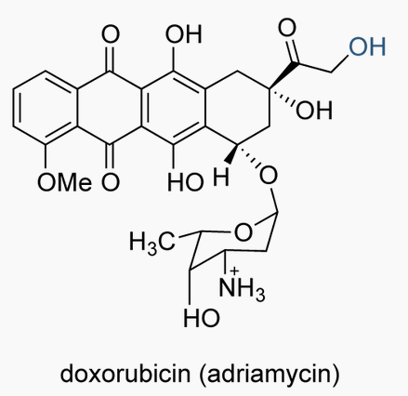**doxorubicin**  
        First, in the search for doxorubicin information, it was learned that it goes by other (trade) names, in particular **adriamycin** (indicated to be a former generic name)so many articles could be titled or referenced in that way.  
        It has a formula weight of 543.5 g/mol [CAS Reg #23214-92-8]  
        Additionally, doxorubicin belongs to a class of therapeutics called anthracyclines. The Wikipedia entry on anthracyclines as toxicants shows they are used in chemotherapy against many cancers: leukemia, lymphomas, cancers of breast, uterus, ovary, bladder and lung. A major toxic side effect is cardiotoxicity. Doxorubicin appears to be a synthetic derivative of the natural anthracycline daunorubicin which is a product of a *Streptomyces* species. Drugs are typically obtained from bacteria or sometimes fungi and then derivatized especially when the natural form has a property that makes it ineffective (development of resistance) or perhaps to enhance absorption or distribution, or resist metabolism and excretion.  
          
        *Pharmacokinetics*Although there were articles published in the literature, they were unaccessible to the College library, so a source found on a web document was used for the PK data [1]Distribution. *V*d = 800-1200 L/m2. 75% will bind plasma proteins with no concentration dependence up to 1.1 µg/ml. Does not cross BBB. A 70 mg/m2 i.v. dose given to lactating patient was found in to be 4.4-fold higher in concentration than the plasma at 24 h, and continued to be detectable up to 72 h. Bioavailability is about 5% after oral dose  
        Metabolism. Thom et al. [1], information on the metabolism of doxorubicin was reported. Anthracycline class toxicants are metabolized by three different routes: one- and two-electron reductions and deglycosidation, all Phase I biotransformations. But 50% of doxorubicin is excreted unchanged from the body, so these metabolic reactions apply to other half of absorbed toxicant. With the two-electron reduction, this produces the C-13 alcohol via aldoketo reductase (AKR1A in heart, CBR1 in liver). One-electron reduction will lead to formation of a semiquinone and are done by mitochondrial NADH dehydrogenases in sarcoplasmic reticulum and mitochondria (NDUFS2, NDUFS3, NDUFS7) and so by cytosolic NADPH dehydrogenase (NQO1) and xanthine oxidase (XDH) and nitric oxide synthases (NOS1, NOS2, NOS3). Deglycosidation occurs in 1-2% of Dox and might occur by reduction (forming deoxyaglycone) or hydrolysis (hydroxyaglycone). The enzymes involved not well-characterized.  
        Excretion. Systemic clearance is 324-809 ml/min/m2 (note that clearance is the related to the volume that passes through excreting organs such as the kidney and liver as well as the amount lost by metabolism). There were gender differences in clearance, with men showing 2.5 times higher rate than women, but men had longer half-life than women 54 v. 35 hours. Clearance rates are higher in pediatric patients (1440 ml/min/m2) Biliary excretion accounts for 40%, while urinary excretion is 5-12% of unchanged Dox and its metabolites. Liver dysfunction (shown by high bilirubin) reduced clearance. Less than 3% of dose was recovered as metabolite doxorubicinol over a 7 d period. Obesity (> 130% of ideal weight) has a significant effect on clearance (but not *V*d) , reducing it greatly  
        *Pharmacodynamics*. In the paper by Thom et al [4], they illustrate the effects of doxorubicin in the typical cancer cell (see graphic next page on upper left) and in the cardiomyocyte (see graphic next page upper right. Two hypotheses exist for how doxorubicin exerts the intended effect of killing the cancer cell: (1) it intercalates in the DNA helix and inhibits enzymes used in DNA repair and (2) it generates free radicals by oxidation to an unstable semiquinone which then reverts back to Dox but with production of free radical that can damage proteins in membranes and cause lipid peroxidation. For hypothesis (1), there is data that topoisomerase 2 (TOP2A) is inhibited, or enzymes in cell cycle control (MLH1, MSH2, TP53, ERCC2) are affected. For hypothesis (2), NADH dehydrogenases, nitric oxide synthases, and xanthine oxidase may be involved; alternatively Dox might affect glutathione peroxidase, catalase, and SOD and prevent taking out free radicals that would kill the cancer cells.  
        Another but unwanted serious effect of Dox is cardiotoxicity. Again there are two hypotheses for how cardiotoxicity occurs: (1) free radicals produced by iron combined with effect of the metabolite doxorubicinol (This is C-13 reduction of the C-13 carbonyl; C-13 is the red arrow in the structure). (2) disruption of mitochondria. Use of iron chelator dexrazoxane has been shown to reduce Dox cardiotoxicity to support (1) while genetic variants of mitochondrial NAD(P)H oxidase complex are associated with Dox toxicity. Doxorubicinol has been found to interfere with both iron and calcium metabolism: it interferes with sarcoplasmic reticulum Ca-ATPase pump (ATP2A2), the sarcolemmal Na/K ATPase pump (RYR2) and the F0F1 An external file that holds a picture, illustration, etc.
        Object name is nihms286388f1.jpgproton pump (ATP5 gene family). Aldoketo reductases (AKR1C3, AKR1A1, CBR1, CBR3 are candidates are potential targets to prevent formation of doxorubicinol and stop cardiotoxicity. Prevention of ROS or RNS (reactive nitrogen species) from nitric oxide synthases and NAD(P)H oxidases include NCF4, CYBA, and RAC2.  
        Dox is often given with other antineoplastics (taxanes, platinum-based compounds, nitrogen mustard analogs, fluoropyrimidine, vinca alkaloids). Drug-drug interactions have been identified with phenytoin and cyclosporine (effect on efflux transporter ABCB1), and with sorafenib (by RALBP1)  
           
        [1] http://www.drugs.com/pro/doxorubicin.html  
        [2] Thorn Caroline F, Oshiro Connie, Marsh Sharon, Hernandez-Boussard Tina, McLeod Howard, Klein Teri E, Altman Russ B. Doxorubicin pathways: pharmacodynamics and adverse effects. *Pharmacogenetics and genomics* (2010).
     2. **An external file that holds a picture, illustration, etc.
        Object name is nihms286388f2.jpgclonidine**Also goes by trade names Catapres, Kapvay, Nexicion. Has a formula weight of 230.1 g/mol [CAS 4205-90-7]. It is an imidazolamine which acts as an alpha2-adrenergic agonist.*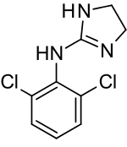Pharmacokinetics*. Distribution: *V*d = 3.1 L/kg Absorption: crosses BBB  
        bioavailability of 70-80%, peak levels attained -1-3 hous  
        Metabolism: 50% of absorbed dose metabolized by liver  
        Excretion: system clearance is ~4 ml/min/kg and there is a half-life of 7.4-9.2 h, 40-60% dose eliminated unchanged*Pharmacodynamics*. This toxicant is an a-adrenoreceptor agonist having both central and peripheral nervous system effects It has hypotensive abilities: in hypothalamus it decreases blood pressure. In allows differential diagnosis of pheochromocytoma where hypertension exists  
        As epidural it is adjunct in managing severe cancer pain  
        • prophylaxis of vascular migraine  
        • severe dysmennorhea treatment  
        • managing vasomotor systems in menopause (hot flashes?)  
        • detox of opiate & alcohol withdrawal when also used with benzodiazepines  
        • managing nicotine dependence  
        • reduces intraocular pressure in glaucoma associated with hypertension• ADHD treatment  
          
        [1] Frisk-Holmberg M, Edlund PO, Paalzow L (1978) Pharmacokinetics of clonidine and its relatin to the hypotensive effect in patients.  
          
        [2] http://www.drugbank.ca/drugs/DB00575
     3. 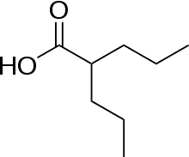valproic acid (VPA)  
          
        This is 2-propylpentanoic acid but also goes by the name dipropylacetate (DPA) with formula weight of 144.2 g/mol  
        [CAS 99-66-1  
        *Pharmacokinetics*.

Absorption: Doses of 8-9 mg/kg. Plasma levels reach maximum to 70 µg/ml after 1-2 h time lag then rapidly peak in 3-4 h.   
Distribution: ~*V*d = 0.13-0.16 L/kg. 95% plasma protein binding. Bioavailability   
Metabolism:

Excretion: Systemic clearance of 10-13 ml/min. Approximate half-life is 8-9 h  
  
  
  
  
*Pharmacodynamics*.  
  
  
  
  
  
[] Klotz U (1977) Pharmacokinetic studies with valproic acid in man. Arneimittelforschung 27: 1085-1088 (used only abstract data):

**Shepherd**: PK: 87-95% plasma protein binding (Leppik & Birnbaum). Metabolism: glucuronidation, beta-oxidation, CYP450 oxidation..metabolized in mitochondria as fatty acid. PD: affects GABA in brain, block voltage-gated ion channels (Ghodke-Puranik),

* 1. Select one of the cytochrome P450 enzymes below in the (a) through (d) list, and describe it as thoroughly as possible in points (i) through (v) below. You should cite at least one reference to a peer-reviewed publication or to a monograph for the course. For any information you put in your response, ensure that it is sourced/referenced. Your response will be compared to the information in the reference  
     1. Provide a description of the type of substrates it metabolizes and give an example of one substrate it is known to metabolize.
     2. Explain the mechanism of catalysis (you can even draw the steps)
     3. Provide the names of any substances known to inhibit the cytochrome, if any
     4. If its gene and/or protein structure is known, describe the domains (functional parts or features) of the enzyme, and any molecular detail/features that are interesting or significant to the enzyme’s function
     5. Provide, if any, known enzyme kinetic parameters: turnover/catalysis rate, etc

1. 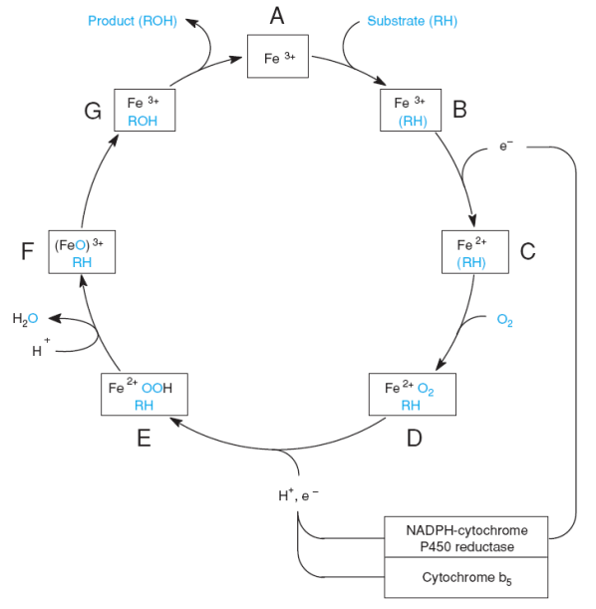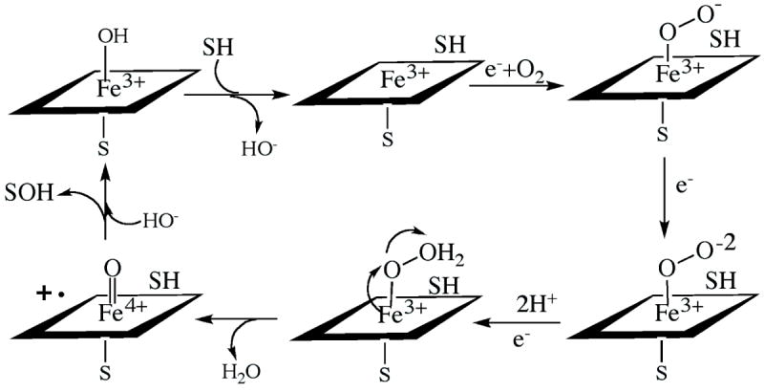CYP3A4  
   To review the nomenclature of the cytochrome P450 enzymes, CYP3A4 refers to isoform 4 within subfamily A of family 3 of the cytochrome P450 series. The criteria for family grouping is at least 40% amino acid sequence identity, while for subfamily grouping it is 55% identity.  
   It should be noted that most toxicants (drugs) processed in the liver are metabolized by CYP1, CYP2, and CYP3 families. 79% of toxicants are processed by CYP3A4/5, CYP2C9, CYP2D6, and CYP2C19  
   *Substrates*. CYP3A4 has very broad substrate specificity and is usually able to oxidize over half of administered drugs. It can activate procarcinogens and thus exert a genotoxic effect. The pharmaceutical industry has been trying to understand this cytochrome P450 3A4 because of its broad effects in reducing bioavailability (increasing elimination). Imatinib is a tyrosine kinase inhibitor used to treat leukemias (ALL, CML). The IV mTOR inhibitor temsirolimus is metabolized by CYP3A4. Because phenytoin is an inducer of CYP3A4, drug manufacturers would likely recommended increased dosage to achieve an effect whenever an inducer like phenytoin is also being prescribed. Omeprazole is a substrate which can cause toxicity of tacrolimus   
   *Catalytic mechanism*. Interestingly, the catalytic cycle of cytochrome P450 is understood differently than in the textbook. From the mechanism discussed in class (figure at left below), substrate binds to the Fe3+ form of the enzyme and one electron is transferred from either NADPH cytochrome P450 reductase of cytochrome *b*5 to form the Fe2+ form. O2 then binds to the Fe2+ iron. Then another electron with proton (H+) is passed to the enzyme to form a semi-hydroperoxide in complex with the iron. A 2nd proton then reacts with the iron-semihydroperoxide to take away a H2O molecule which forms the reactive species (Fe=O)3+ and it is this species that hydroxylates the substrate, which exits. In the other mechanism, two electrons are added with the two H+, but the oxidation state of iron never goes to Fe2+ (reduction) but rather the electrons are added first to form superoxide anion and then the hydroperoxide. After release of the water, Fe3+ had to give up an electron to form Fe4+ coupled to a singlet oxygen. This hydroxylates the bound substrate, and the heme iron is returned to 3+ state.  
     
   *Inhibitors*. Imatinib, azole antifungals, simvastatin. Grapefruit juice inhibits intestinal enterocyte CYP3A4  
   *Gene/ and protein structure*. The most abundant of the 57 human P450s, metabolizing most drugs. It is expressed mainly in the liver and GI tract.  
   *Enzyme kinetic parameters*. The velocity versus substrate concentration plot which is basic to understanding the action of enzymes does not show typical hyperbolic (Michaelis-Menten) kinetics, but rather a sigmoidal (biphasic) curve in the substrates which were first identified for CYP3A4 (testosterone, progesterone, alpha-naphthoflavone, etc). This sigmoidal curve is typical of allosteric activation of a multisubunit enzyme or in which there might be multiple substrate binding. Site-directed mutagenesis studies have identified residues involved in substrate binding, cooperativity, and regioselectivity: F108, S119, I120, L211, D214, I301, F304, A305, T309, A370, and L373. Crystal x-ray structures indicate these residues are at the active site or substrate access (see figure). Substrate binding experiments with testosterone show a Hill coefficient *n*H = 2, indicating two molecules can bind, but other types of experiments show up to three testosterone can bind. What was learned is that a 2nd testosterone molecule is necessary to increase product formation, but the 3rd molecule increases “coupling efficiency”: that is, the consumption of electrons and formation of metabolites.  
   An external file that holds a picture, illustration, etc.
   Object name is nihms412689f2.jpg  
     
     
     
     
     
     
   [1] McDonnell AM, Dang CH (2013) Basic review of cytochrome P450 system. *J. Adv. Pract. Oncol.* **4**: 263-268.  
   [2] Sevrioukova IF, Poulos TL (2013) Understanding the mechanism of cytochrome P450 3A4: recent advances and remaining problems. *Dalton Trans.* **42**: 3116-3126.
2. CYP2C9  
     
   *Substrates*.   
   *Catalytic mechanism*  
   *Inhibitors*. 4  
   *Gene/ and protein structure*. iver and GI tract.  
   *Enzyme kinetic parameters*. Tc
3. CYP1A1  
   probably plays huge role in activating procarcinogens. Acts on both xenobiotics and endogenous compounds.  
   *Substrates*. Acts on environmental carcinogens and on dietary compounds with anti-cancer activity. Carcinogens are activated to epoxides. Classical substrate is benzo[a]pyrene (BaP), forming the 4,5-epoxide (K-region epoxide), but also 7,8-diol-9,10-epoxides (bay region epoxides) are also DNA highly reactive. Epoxidation to the 7,8-oxide leads to hydrolysis to three product: 7,8-diol and two enantiomers: +-7,8-diol and –-7,8-diol.  
   *Catalytic mechanism.* Hydroxylation of C-H substituent (vacant part) of aromatic ring is thought to be its target.   
   *Inhibitors*. 4  
   *Gene/ and protein structure*. This P450 enzyme located in tissues outside the liver. Because it acts most likely on PAHs, its induction probably under control of AhR, with binding of environmental pollutants and inhalational chemicals.  
   *Enzyme kinetic parameters*  
     
   [1] Androutsopoulos VP, Tsatsakis AM, Spandidos DA (2009) Cytochrome P450 CYP1A1: wider roles in cancer progression and prevention. *BMC Cancer* 9: 187.
4. CYP2D6  
   *Substrates*.   
   *Catalytic mechanism*  
   *Inhibitors*. 4  
   *Gene/ and protein structure*. iver and GI tract.  
   *Enzyme kinetic parameters*  
     
     
     
     
     
     
     
     
   1. Select (a) or (b) or (c) to answer:
      1. Find at least one report/article that discusses the differences in how men and women respond to toxicants or drugs. Your search for an article may focus on one particular toxicant/drug or you may summarize an article that treats these differences in a broad survey. In any article you obtain, be sure to indicate at least three significant points, but list all of them if there are more.
      2. Hepatocytes have several different efflux transporters in the plasma membrane that forms the canalicular wall. In the literature there are many original articles and reviews of these canalicular efflux transporters. Pick two of the transmembrane proteins, give their names, describe what substances are known to be transported by them (or class of substances). Explain what is known about their function and include any details of known mechanisms (the “molecular machinery and gears”), such as cellular substrates required to make them work. Summarize what is known about how they are regulated: what turns them on or off, or what increases or decreases their activity, including regulation of gene expression, or signaling pathways the modify protein activity and/or de novo synthesis.
      3. Search for a nephrotoxic substance (toxicant, poison or drug). Explain what part(s) of the nephron it disrupts (describe the mechanism of toxicity). Describe how normal kidney physiology would be disrupted for the parts of the nephron affected. Describe how the nephrotoxic substance is detoxified (metabolism? elimination? both?) What doses or concentration levels are required to obtain the toxic effect?